

SOFTWARE DESIGN & ARCHITECTURE

Complex Engineering Activity

ONLINE DESIGN TOOL – GUI

Laiba Rehman – 505099
Muhammad Aashir Aslam – 506616
Ameer Usman – 509042
Syed Muhammad Ali Jawad - 510557
Muhammad Hassan - 508806
Muhammad Arsal Saeed – 506676

SE 30 B
Submitted to: Snr Lec Fawad Khan

Date: 6th April 2026
Military College of Signals
NUST

1. PROJECT OVERVIEW AND INTRODUCTION

1.1 Brief Description of the Project
The Online Design Tool (ODT) is a web-based Computer-Aided Software Engineering (CASE) tool developed. It is a single-page React and TypeScript application that enables software engineering students and teams to create, edit, validate, and export UML diagrams following the 4+1 Architectural View Model.
The tool supports both authenticated users through Supabase cloud storage and guest users through browser-based local storage, making it accessible regardless of user account status. It allows users to select from multiple software architecture templates, draw UML elements on an interactive canvas, validate the structural correctness of their diagrams, and generate starter code in Java and C++.

1.2 Online Design Tool (ODT)
An Online Design Tool is a browser-based application that provides software engineers, architects, and students with the capability to create visual software models and architecture diagrams without installing any dedicated software. Unlike traditional desktop applications such as MS Visio or Visual Paradigm, an ODT operates entirely within a web browser, making it platform-independent and immediately accessible.
The ODT developed in this project specifically targets UML-based software modeling, supporting nine distinct diagram types across five architectural views. It combines drawing capabilities with automated validation and code generation, making it a complete CASE tool rather than a simple diagramming application.

1.3 Inspiration from Existing Tools
The ODT draws design inspiration from five categories of existing software tools, taking the strongest feature from each:
- MS Paint: Simplicity of the drawing interface. Paint introduced the concept of a canvas-centered workspace with a minimal side toolbar. The ODT adopts this layout philosophy, ensuring the diagram canvas remains the dominant interface element.
- MS Word: Document management features including saving, opening, and organizing named files. The ODT mirrors this with its project dashboard where diagrams are organized as named workspaces.
- MS Visio: Structured diagramming with shape libraries and connector logic. Visio introduced the concept of snapping connectors to shapes and enforcing diagram types. The ODT applies these ideas through its shape palette and connector creation rules.
- Visual Paradigm: Deep UML support including multiple diagram types, validation engines, and code generation. The ODT adapts this at an educational scale by supporting the 4+1 view model and implementing a rule-based UML validation engine.
- Online Tools such as Lucidchart and Draw.io: Cloud persistence, guest access, and browser-based rendering without installation. The ODT directly incorporates these ideas through Supabase cloud storage and its localStorage guest mode.

1.4 Problem Being Solved
Existing professional CASE tools present a significant barrier for students. MS Visio requires a paid Windows license. Visual Paradigm has a steep learning curve with hundreds of features irrelevant to coursework. Lucidchart is subscription-based. Draw.io, while free, lacks UML validation and code generation.
The ODT solves the problem of the educational tool gap. It provides a free, browser-based, UML-focused environment that includes the three features most valuable student’s coursework structured diagram creation tied to the 4+1 model, automated UML validation with clear error messages, and code generation to demonstrate the connection between design and implementation. Students can begin using the tool immediately without installation, cost, or extensive training.

2. HIGH-LEVEL DESIGN: ARCHITECTURAL STYLE

2.1 Selected Architectural Style: Hybrid Layered Architecture with MVC
The ODT uses a Hybrid Layered Architecture as its primary structural style, combining four distinct horizontal layers with the Model-View-Controller pattern applied within the presentation layer. This combination was selected after evaluating the four main architectural styles covered in the curriculum: Layered Architecture, Client-Server, MVC, and Pipe-and-Filter.

2.2 The Four-Layer Structure
The ODT organizes all system components into four horizontal layers. Each layer communicates only with the layer directly below it, which enforces information hiding and makes individual layers replaceable without affecting the rest of the system.
- Layer 1: Presentation Layer This is the browser-rendered user interface. It contains all React components that the user sees and interacts with, including the Dashboard, Editor, Canvas, Shape Palette, Properties Panel, Validation Panel, and Code Generation Panel. No business logic resides in this layer. Its only responsibility is rendering state and forwarding user actions to the layer below.
- Layer 2: Application Layer This layer contains the service objects that orchestrate system behavior. DiagramService manages the lifecycle of diagrams. ExportService generates PNG, SVG, and DOCX files. AuthService handles user authentication state and session management. This layer translates user actions from Layer 1 into operations on the domain model in Layer 3.
- Layer 3: Domain Layer This is the core business logic of the ODT. It contains the UML validation engine, which enforces structural rules such as class names being properly capitalized, connectors having valid source and target types, and inheritance cycles being absent. It also contains the code generator, which converts class diagram elements into Java or C++ source code, and the architecture template engine, which loads the correct shape palette and seed elements for each architecture style.
- Layer 4: Data and Infrastructure Layer This layer manages all persistence. For authenticated users, it communicates with the Supabase PostgreSQL database and the Supabase Object Storage bucket. For guest users, it writes to and reads from the browser localStorage. Redis is used as a write-through cache to absorb the high-frequency writes generated during live canvas editing.

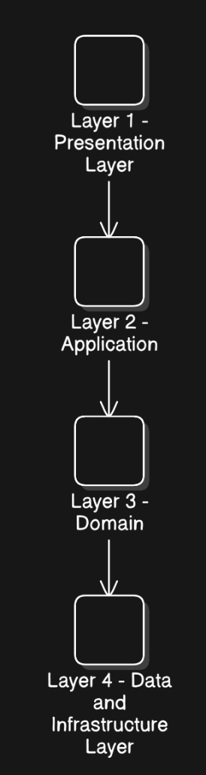
Figure 1: ODT Hybrid Layered Architecture - Four horizontal layers

2.3 MVC Within the Presentation Layer
Within Layer 1, the Model-View-Controller pattern is applied to the diagram editing workflow. This secondary pattern is justified because the canvas editing feature is the most complex interaction in the system and requires a clean separation between the data being edited and its visual representation.
- Model: The DiagramModel holds the complete in-memory state of the diagram being edited. This includes all elements with their positions and type-specific properties, all connectors with their source, target, and relation type, and the current viewport offset and zoom level.
- View: The Canvas component renders the DiagramModel as an SVG graphic in the browser. It reads the model state and produces the visual output. It never modifies the model directly.
- Controller: The Editor component sits between the Canvas and the DiagramModel. It receives all user interaction events from the Canvas, such as drag, click, delete, and connection creation, applies them to the DiagramModel, and then triggers a re-render of the Canvas with the updated state. It also manages the autosave timer and routes save operations down to Layer 2.

2.4 Client-Server Boundary
At the infrastructure level, the ODT also operates as a Client-Server system. The React application running in the browser is the client. Supabase provides the server, hosting the PostgreSQL database, the authentication service, and the object storage bucket. All client-server communication happens through the Supabase JavaScript SDK, which translates JavaScript function calls into authenticated HTTPS API requests. This boundary means all data validation and access control enforced at the database level through Row Level Security policies cannot be bypassed by the client.

2.5 Justification
The Hybrid Layered and MVC combination was chosen over pure alternatives for three specific reasons:
- Separation of Concerns: The layered structure ensures that changing the database, for example switching from Supabase to a self-hosted PostgreSQL instance, requires changes only in Layer 4. The validation rules in Layer 3 and the UI components in Layer 1 are entirely unaffected. This was validated during development when the storage provider was changed with no impact on the canvas or validation code.
- Testability of Business Logic: Because the validation engine and code generator are isolated in Layer 3 with no direct dependency on UI components or the database, they can be unit-tested independently. Each validation rule can be exercised in isolation without rendering a browser or connecting to a database.
- Scalability for Real-Time Use: The Redis cache in Layer 4 directly addresses the known performance limitation of Layered architectures. Without caching, every mouse move during editing would produce a database write. Redis absorbs all per-keystroke writes and flushes them to PostgreSQL at 30-second intervals or on manual save.

3. MID-LEVEL DESIGN: GUI SCREENS
The ODT user interface is divided into six primary screens. Each screen is described below with its purpose, the components it contains, and guidance on where to insert the corresponding screenshot or wireframe image.

3.1 Login and Registration Screen
The Login screen is the entry point for authenticated users. It presents a centered card with two input fields for email and password, a login button, and a link to the registration form. A separate Guest Access button is prominently displayed below the login form, allowing users to proceed directly to the dashboard without creating an account. In guest mode, all data is stored in the browser localStorage and is not synchronized to the cloud.
The registration form mirrors the login layout with the addition of a username field and a password confirmation field. Both forms include inline error messages for invalid credentials, unmatched passwords, and duplicate email addresses.
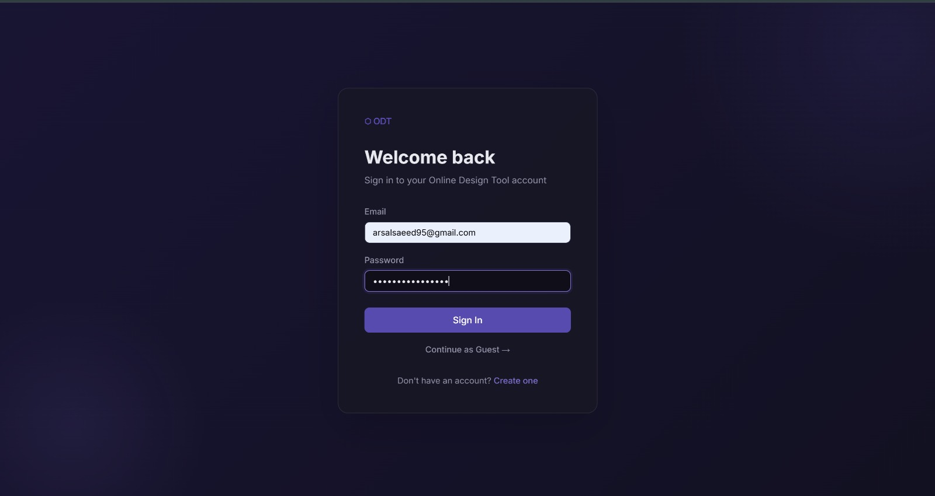
Figure 2: ODT Login Screen showing authenticated and guest access options

3.2 Home Screen / Dashboard
The Dashboard is the central project management screen. It displays a grid of project cards, where each card shows the project name, the selected architecture style, the number of diagrams in the project, the last modified timestamp, and a validation status badge indicating whether the diagrams pass UML structural rules.
A prominent Create New Project button opens a modal dialog where the user enters a project name and selects an architecture style from a dropdown list. The available styles are Layered, MVC, Client-Server, Pipe-and-Filter, SOA, and Component-Based. Selecting a style automatically populates the new project with five template diagrams corresponding to the 4+1 view model, with pre-seeded starter shapes appropriate to the chosen architecture.
Each project card has a Delete button, which removes the project and all associated diagrams after a confirmation prompt. A user avatar and logout link are visible in the top-right corner of the screen.
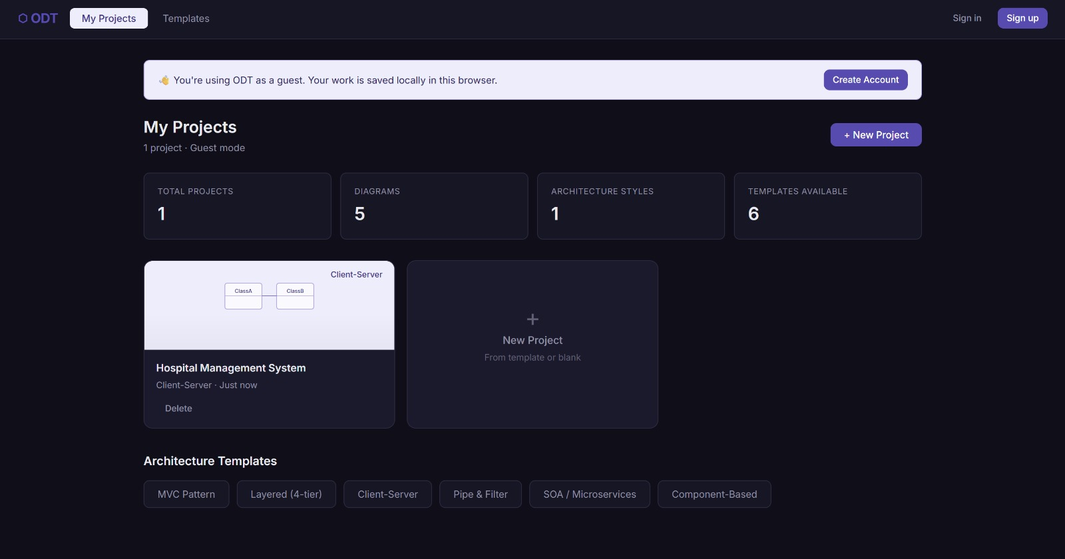
Figure 3: ODT Dashboard showing project cards with architecture styles and validation status

3.3 Architecture Template Selection
When creating a new project, the user encounters the architecture selection interface before the editor opens. This screen presents six architecture templates as selectable option cards arranged in a two-column grid. Each card shows the architecture name, a brief one-sentence description, and an icon representing the structural pattern.
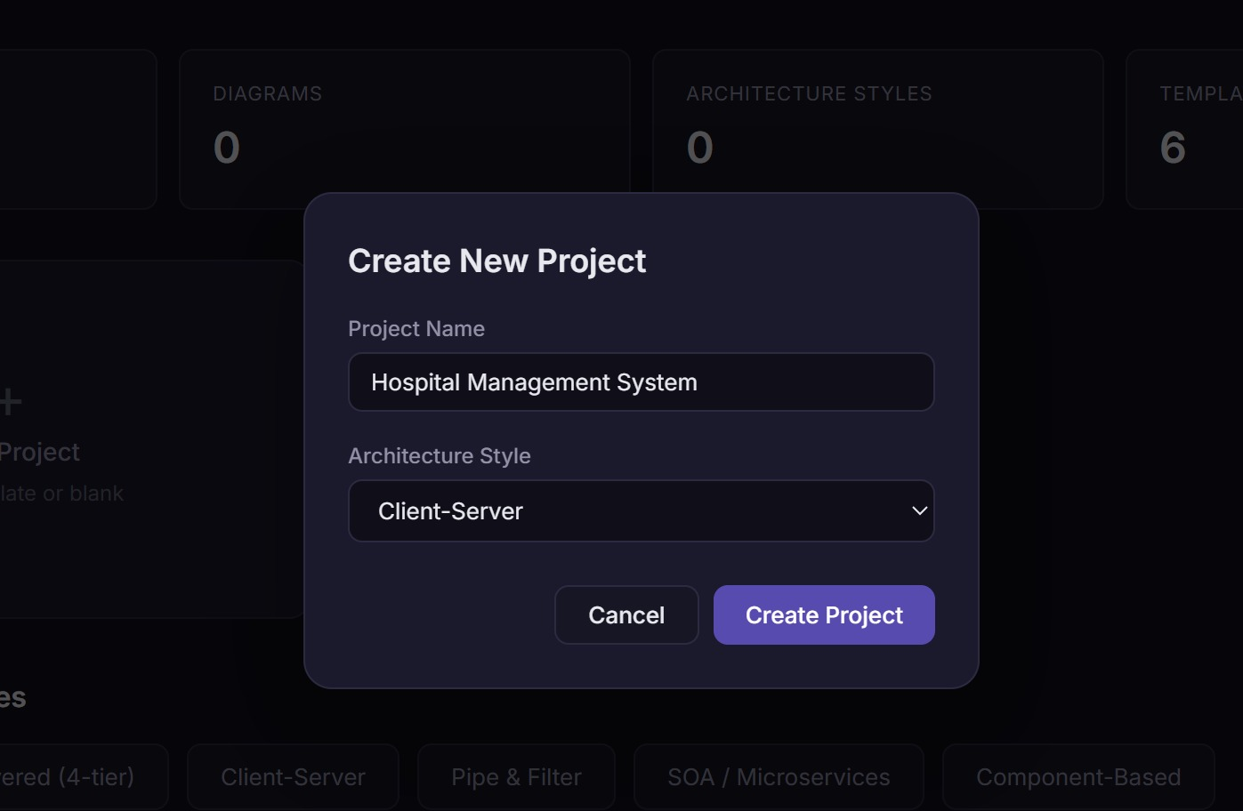
Figure 4: Architecture Template Selection Card
Selecting a template and confirming the selection triggers the template engine, which creates five diagrams in the new project, one for each 4+1 view, and seeds each diagram with the default elements and connectors defined for that architecture style. For example, selecting Layered creates a Logical View diagram pre-populated with four stacked layer boxes and dependency arrows between them.

3.4 Canvas and Drawing Area
The Editor screen is the primary working environment. It is divided into three panels arranged horizontally. The left panel is the Shape Palette, which displays the UML elements available for the currently active diagram type, such as ClassBox, Interface, Package, and Note for Class diagrams. Elements are dragged from the palette onto the central canvas.
The central panel is the SVG Canvas, which renders all diagram elements and connectors. Elements can be selected by clicking, moved by dragging, and deleted using the Delete key. Connectors are drawn by clicking on a source element's connection port, dragging to the target element, and releasing. The connector type is set through a dropdown in the Properties Panel. The canvas supports pan using click-and-drag on the background and zoom using the scroll wheel.
The right panel is the Properties Panel, which shows the editable attributes of the currently selected element. For a ClassBox, this includes the class name, a list of attributes with name and visibility fields, and a list of methods with name, return type, and visibility fields. For a connector, it shows the relation type and multiplicity values.
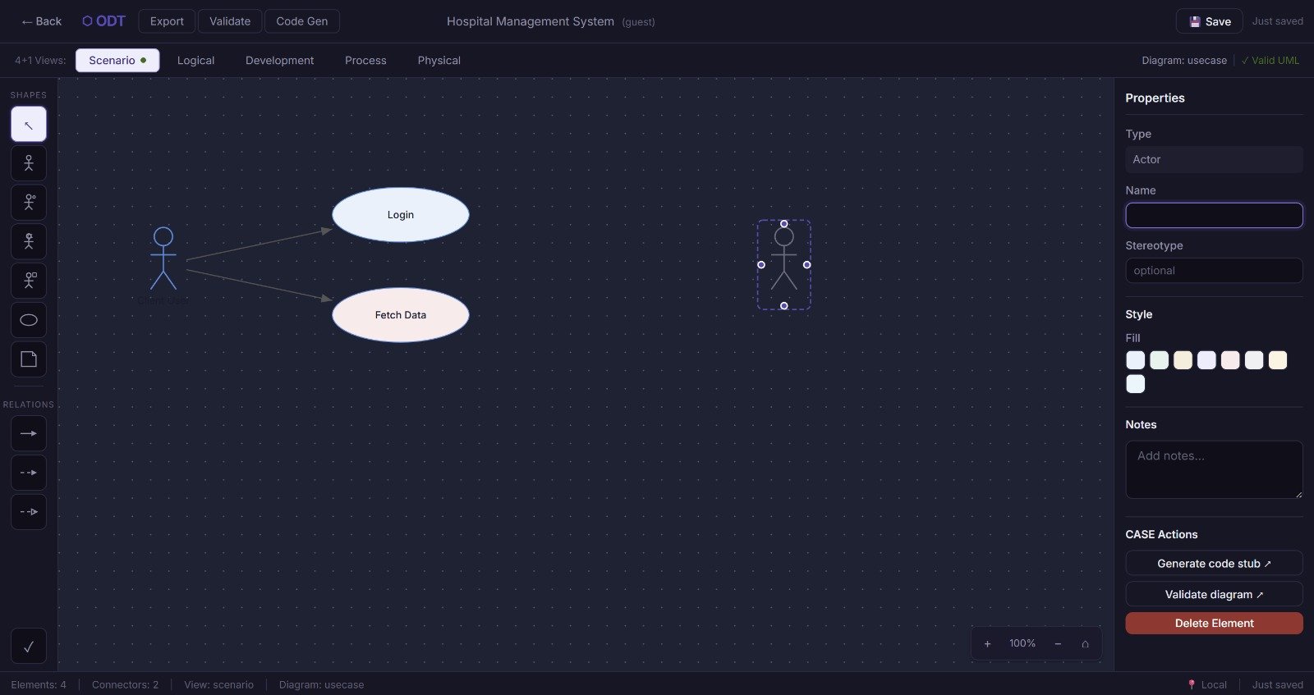
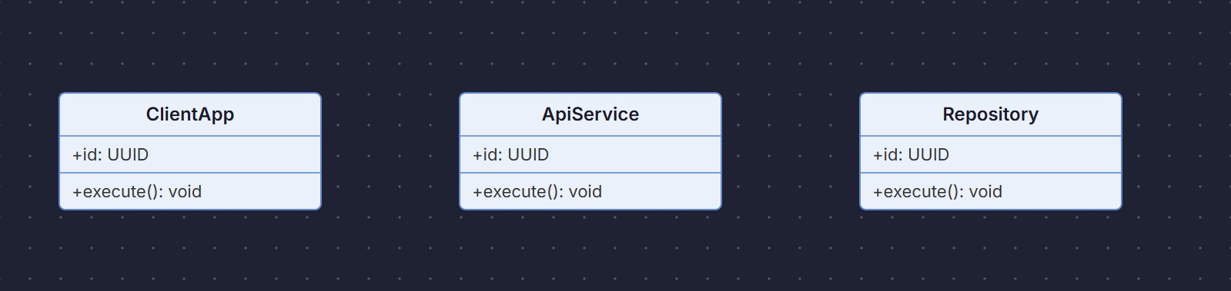
Figure 5: ODT Editor showing Shape Palette, SVG Canvas, and Properties Panel

3.5 Diagram Editing Interface and View Switching
At the top of the Editor screen, a row of tabs represents the five 4+1 views: Scenario, Logical, Development, Process, and Physical. Clicking a tab switches to the diagram for that view. Before switching, the current diagram's state is automatically saved to prevent data loss.

A toolbar row beneath the tabs contains: a Validate button that triggers the UML validation engine for the active diagram, a Generate Code button that opens the Code Generation panel, and an Export button that generates a downloadable PNG or SVG file of the current canvas.

Figure 6: 4+1 View tabs and action toolbar

3.6 Validation Panel and Code Generation Panel
When the Validate button is clicked, the Validation Panel slides in from the right side of the Editor, replacing the Properties Panel. It displays a list of validation issues, where each issue shows a rule identifier, a severity level of either Error or Warning, the name of the element that failed the rule, and a plain-English description of the problem. Clicking an issue in the list selects the problematic element on the canvas, scrolling and centering it in the viewport if needed.
The Code Generation Panel is accessible from the Generate Code button and is available only for Class diagram views. It displays a tabbed interface with two tabs: Java and C++. The generated code is shown in a scrollable monospace text area. A Download button below the text area triggers a file download of the displayed code with the appropriate file extension.
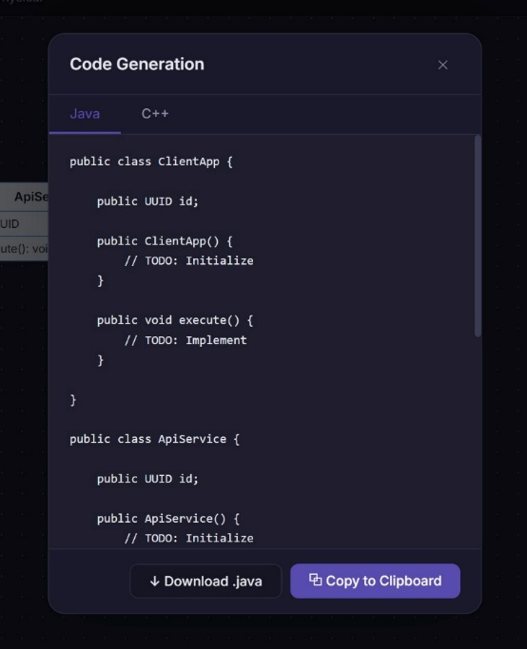
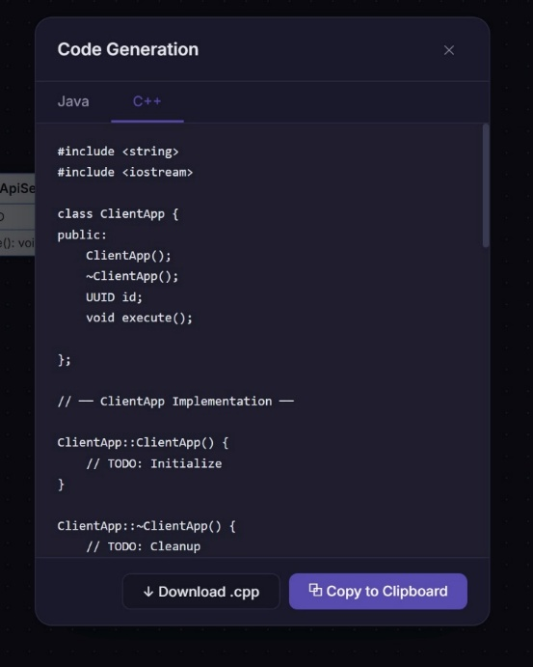

Figure 7: Code Generation Panel with Java (left) Code Generation Panel with C++(right)

3.7 File Management: Save and Export
The ODT uses an autosave system rather than a manual save dialog. Diagram state is saved automatically one and a half seconds after the user stops making changes, which prevents accidental data loss without interrupting the editing workflow. A small status indicator in the top bar of the Editor shows Saving, Saved, or Unsaved to inform the user of the current persistence state.
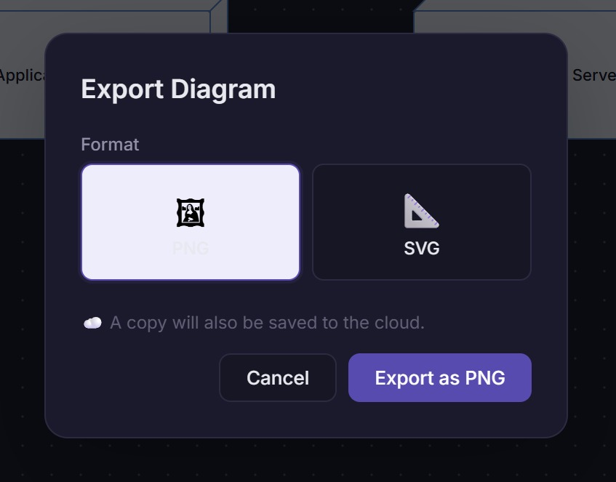
The Export functionality is accessed through the Export button in the toolbar. It triggers a dropdown menu with four options: Export as PNG, Export as SVG, Export as PDF, and Export as DOCX. For authenticated users, the exported file is also uploaded to the Supabase Object Storage bucket and a permanent download URL is recorded in the EXPORTS table. For guest users, the file is generated in-browser and downloaded directly without any cloud upload.

Figure 8: ODT Export Menu showing available diagram export formats

4. LOW-LEVEL DESIGN: SOFTWARE DESIGN PATTERN

4.1 Selected Pattern: Observer Pattern combined with Factory Method
After evaluating the design patterns, the ODT implementation uses two complementary patterns. The Observer pattern governs how the canvas reacts to model changes, and the Factory Method pattern governs how new UML elements are created on the canvas. Together, they address the two most technically demanding aspects of a real-time diagramming tool.

4.2 Observer Pattern: Implementation and Justification
The Observer pattern defines a subscription mechanism that allows one object, called the Subject, to notify a list of dependent objects, called Observers, automatically when the subject's state changes. In the ODT, this pattern maps directly onto the relationship between the DiagramModel and all components that display or process diagram content.
How it works in the ODT:
- The Subject is the DiagramModel. It maintains the canonical state of the diagram being edited, including all elements, connectors, positions, and viewport settings. When any part of this state changes, the DiagramModel emits a stateChanged event.
- The Observers are three components: the Canvas component, which re-renders the SVG drawing; the ValidationPanel, which re-runs structural checks and updates the error list; and the autosave service, which debounces the event and triggers a persistence write after 1500 milliseconds of inactivity.
- The Subscription mechanism is implemented through React's useState and useEffect hooks in the TypeScript frontend, which create reactive subscriptions between the model state and the component render functions. When the model state variable is updated, React schedules a re-render of all components that read from it.

Why Observer was chosen over Mediator:
The Mediator pattern was also considered because it reduces direct coupling between components. However, Mediator introduces a central mediator object that must know about all component interactions, which grows complex as features are added. The Observer pattern requires less coordination overhead because components subscribe to the model directly rather than routing all events through a central hub. Since the DiagramModel is a stable, clearly-defined object, Observer is the more maintainable choice.

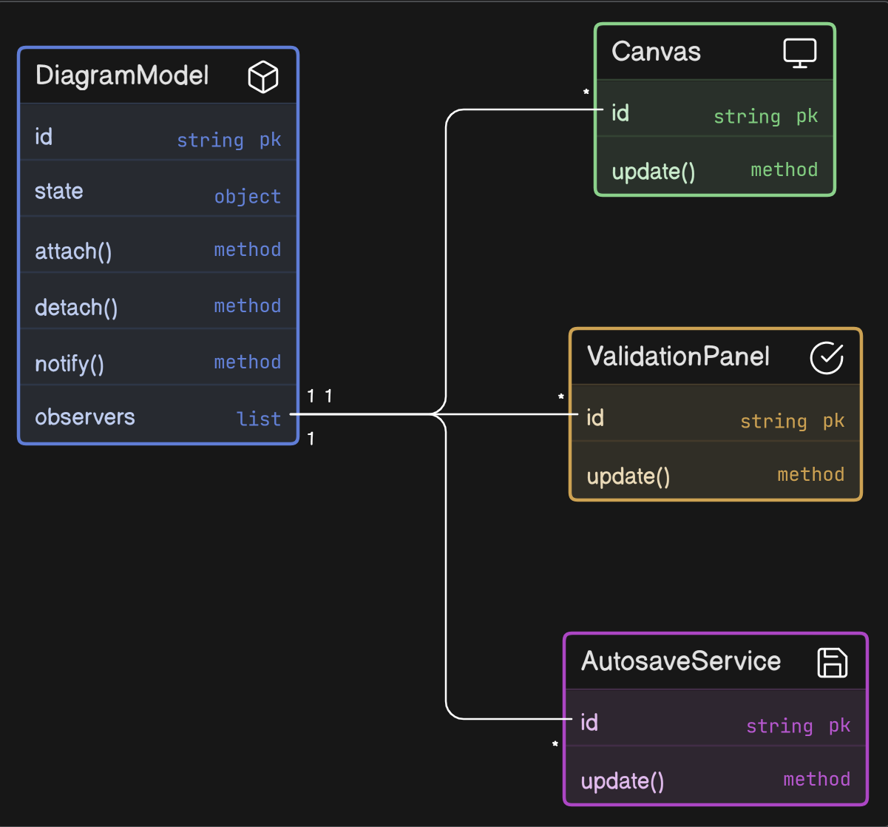
Figure 9: Observer Pattern showing DiagramModel as Subject and its three Observers

4.3 Factory Method Pattern: Implementation and Justification
The Factory Method pattern defines an interface for creating objects but lets subclasses decide which class to instantiate. In the ODT, this pattern is used by the ShapeFactory to create the correct UML element object based on the element type selected by the user in the Shape Palette.
How it works in the ODT:
- The Creator is the abstract ShapeFactory class, which declares the createShape(type, position) factory method.
- The Concrete Creators are subclasses for each architecture template: MVCShapeFactory, LayeredShapeFactory, ClientServerShapeFactory, and so on. Each subclass overrides createShape() to return only the element types valid for that architecture's palette.
- The Product is the abstract UMLElement interface. Concrete Products are ClassBox, Actor, UseCase, Component, DeploymentNode, Interface, Package, and Note, each implementing the UMLElement interface with their specific property structures.
- The Client is the Editor component. When a user drags a shape from the palette and drops it on the canvas, the Editor calls ShapeFactory.createShape(type, dropPosition). The Editor never references ClassBox or Actor directly, only the UMLElement interface. This means new element types can be added by creating a new Concrete Product class and registering it with the appropriate factory, without modifying the Editor.

Why Factory Method was chosen over Singleton:
The Singleton pattern was considered for managing the single canvas state object. However, Singleton would create a global shared object that makes the system difficult to test, since tests cannot easily create isolated instances. Factory Method gives the system the ability to create fresh, independent element instances for each diagram, which is essential for supporting multiple diagrams open across different browser tabs and for running validation on one diagram without affecting another.

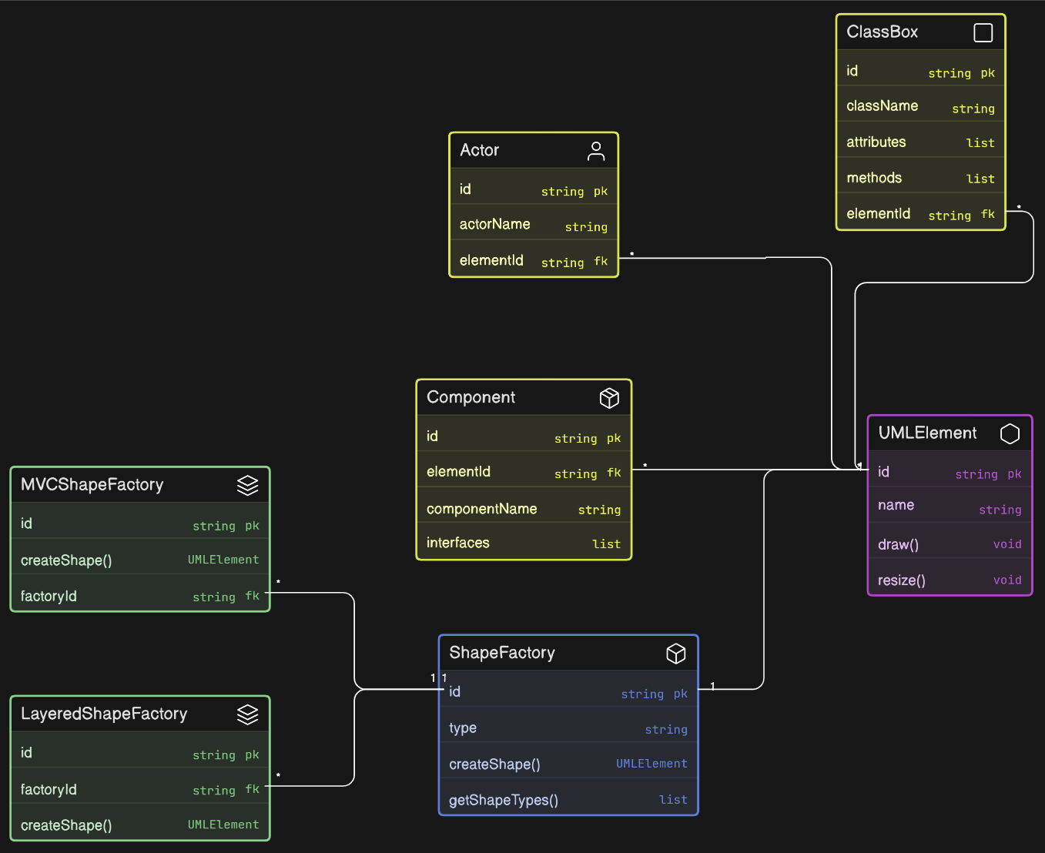
Figure 10: Factory Method Pattern - ShapeFactory hierarchy and UMLElement product hierarchy

4.4 What Problems These Patterns Solve in ODT
- Without Observer: Every time a user moves an element on the canvas, the Editor would need to explicitly call Canvas.rerender(), ValidationPanel.refresh(), and autosaveService.schedule() in sequence. Adding a new component that needs to react to model changes would require modifying the core editing code. Observer eliminates this tight coupling.
- Without Factory Method: The Editor would contain a large switch statement that directly instantiates ClassBox, Actor, UseCase, and so on based on the selected type. Adding a new element type would require modifying the Editor's core switching logic. Factory Method encapsulates this decision in dedicated factory classes.

5. DATABASE DESIGN

5.1 Overview and Technology Selection
The ODT uses PostgreSQL as its primary relational database and Redis as an in-memory write-through cache. PostgreSQL was chosen for three concrete reasons: its native jsonb column type stores element-specific properties without schema changes; ACID transactions ensure consistency during concurrent multi-user editing; and UUID primary keys allow client-side ID generation without a centralised sequence. Redis absorbs high-frequency writes during live canvas editing and flushes to PostgreSQL every 30 seconds or on manual save.
MongoDB was rejected due to loss of ACID guarantees, and MySQL due to its lack of native jsonb support.

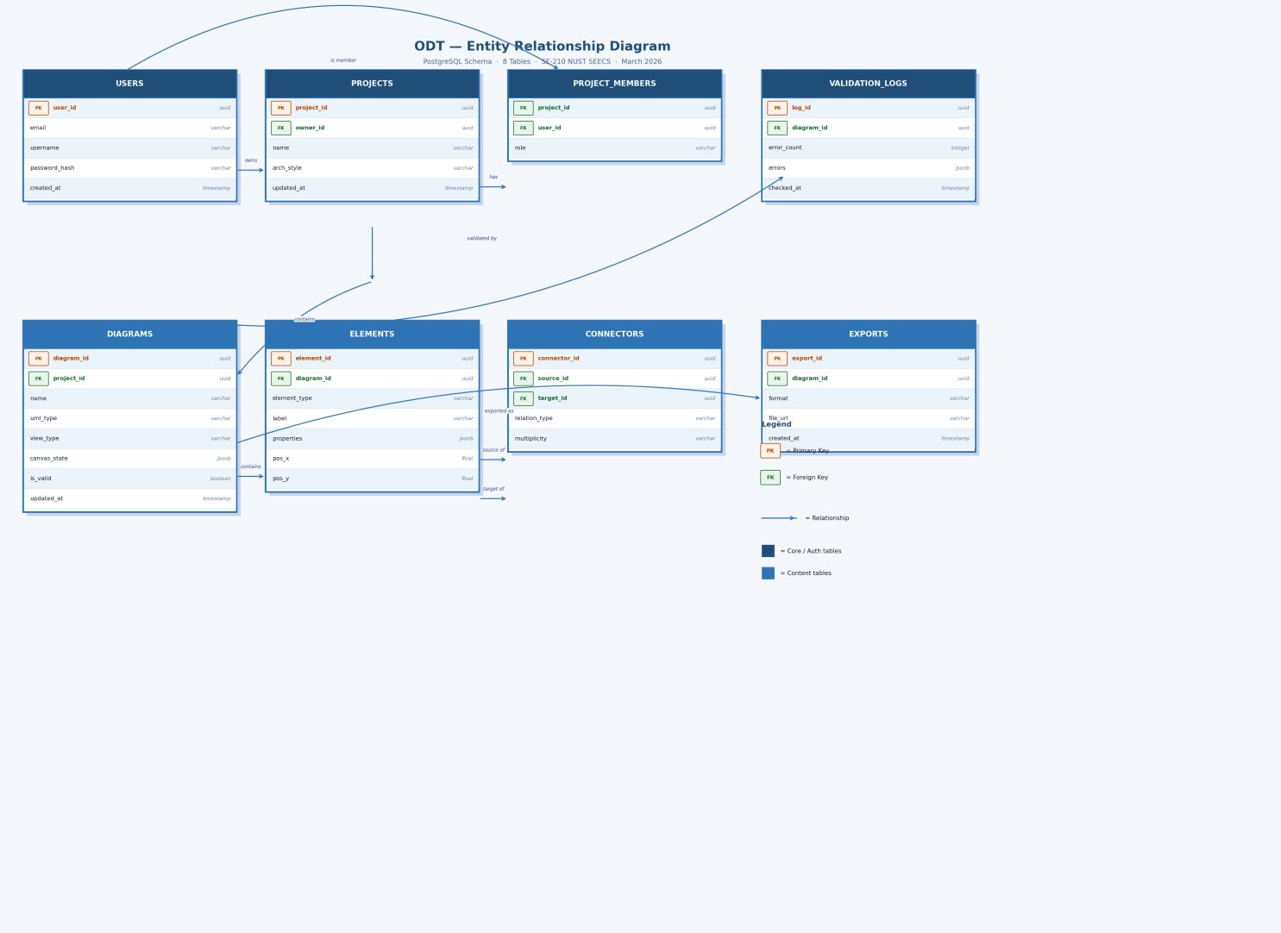
5.2 Entity Relationship Diagram

5.3 Table Schemas (Summary)
Table | Key Columns | Purpose
USERS | user_id (PK, uuid), email (UNIQUE), username, password_hash (bcrypt), created_at | Registered accounts
PROJECTS | project_id (PK), owner_id (FK→USERS), name, arch_style, updated_at | Named diagram workspaces
PROJECT_MEMBERS | project_id (FK/PK), user_id (FK/PK), role (owner|editor|viewer) | Many-to-many collaboration + RBAC
DIAGRAMS | diagram_id (PK), project_id (FK), name, uml_type, view_type, canvas_state (jsonb), is_valid, updated_at | UML diagram canvas state
ELEMENTS | element_id (PK), diagram_id (FK, CASCADE), element_type, label, properties (jsonb), pos_x, pos_y | Shapes on canvas
CONNECTORS | connector_id (PK), source_id (FK→ELEMENTS), target_id (FK→ELEMENTS), relation_type, multiplicity | Directed UML edges
EXPORTS | export_id (PK), diagram_id (FK), format (PDF|PNG|SVG|DOCX), file_url, created_at | Append-only export audit log
VALIDATION_LOGS | log_id (PK), diagram_id (FK), error_count, errors (jsonb), checked_at | Append-only validation history

5.4 Relationships and Key Design Decisions
Parent | Child | Cardinality | Business Rule
USERS | PROJECTS | 1 to 0..* | User owns zero or many projects
USERS / PROJECTS | PROJECT_MEMBERS | M to M | Users collaborate on many projects
PROJECTS | DIAGRAMS | 1 to 1..* | Project must have at least one diagram
DIAGRAMS | ELEMENTS | 1 to 1..* | Elements deleted with diagram (CASCADE)
ELEMENTS | CONNECTORS (src/tgt) | 1 to 0..* | Element may be source or target of many edges
DIAGRAMS | EXPORTS / VALIDATION_LOGS | 1 to 0..* | Append-only; records never deleted

5.5 Key Design Decisions
UUID primary keys are used across all tables to allow client-side ID generation (enabling optimistic UI updates without a server round-trip) and to eliminate sequential ID leakage. JSONB is used for DIAGRAMS.canvas_state (atomic diagram load in one column, no joins) and ELEMENTS.properties (flexible per-type attributes without sparse nullable columns or EAV anti-pattern). EXPORTS and VALIDATION_LOGS are designed as append-only logs—rows are never updated or deleted—providing a full audit trail, eliminating locking conflicts, and enabling analysis of a student’s progress over time.

6. OVERALL SYSTEM EXPLANATION

6.1 How a User Interacts with the System
A first-time user arrives at the ODT login screen. They may register a new account with an email address, username, and password, or click Guest Access to proceed without registration. Registered users receive a Supabase session token that is stored in the browser and refreshed automatically.
After login or guest access, the user lands on the Dashboard. They create a new project by entering a name and selecting an architecture style. The template engine reads the selected style, creates five diagrams in the new project database records, and seeds each diagram with architecture-appropriate starter elements.
The user opens the project, entering the Editor. They switch between the five 4+1 view tabs to work on different diagrams. On each canvas they add elements from the Shape Palette, position them by dragging, and connect them by drawing connectors between element ports. They edit element properties such as class name, attributes, and methods in the Properties Panel.

6.2 How Data Flows Through the System
- User makes a canvas change such as moving an element. The Canvas component captures the drag event and calls the Editor controller with the new position.
- The Editor controller updates the DiagramModel state variable with the new element position.
- React's state update mechanism triggers the Observer subscriptions. The Canvas re-renders the SVG with the element in the new position. The autosave service receives the change event and starts a 1500-millisecond debounce timer.
- After 1500 milliseconds of inactivity, the autosave service calls DiagramService.save(), which writes the current canvas_state as a jsonb object to the Redis cache with the key diagram:{diagram_id}:canvas.
- Every 30 seconds, or when the user navigates away or logs out, the Redis cache is flushed to the PostgreSQL DIAGRAMS.canvas_state column through the Supabase API.

6.3 How Diagrams are Created, Edited, and Saved
Diagram creation happens at the moment a project is created. The architecture template engine generates five DIAGRAMS table rows and populates each with starter elements via ELEMENTS rows and starter connectors via CONNECTORS rows. This all happens in a single database transaction to guarantee that either all five diagrams are created or none are.
Diagram editing is the main activity of the editor. All changes during an editing session are held in the in-memory DiagramModel and written to Redis on the autosave cycle. The DIAGRAMS.canvas_state column in PostgreSQL holds the last fully saved version.
When the user opens an existing diagram, DiagramService.load() first checks Redis for an active session key. If found, it returns the in-progress version from Redis, which may be more recent than the PostgreSQL version. If no Redis key exists, it reads DIAGRAMS.canvas_state from PostgreSQL and reconstructs the DiagramModel from the stored jsonb. This gives the user a seamless experience with no data loss even in the event of a browser crash, as long as the autosave cycle has run at least once.

7. CONCLUSION

7.1 Summary of Design Decisions
The ODT report has presented a complete software design across three levels of abstraction. At the high level, the Hybrid Layered Architecture with an internal MVC pattern for the editor was selected because it enforces strict separation of concerns between presentation, application logic, domain rules, and data infrastructure. This separation makes each layer independently modifiable and testable.
At the mid level, six GUI screens were designed and described to capture the full user interaction flow from login through project creation, diagram editing, validation, code generation, and export.
At the low level, the Observer pattern and Factory Method pattern were selected and implemented. Observer decouples the DiagramModel from all components that need to react to changes, eliminating the need for tight coupling through direct method calls. Factory Method encapsulates the creation logic for UML elements, enabling new element types to be added without modifying the core editor logic.
The database design uses PostgreSQL with eight normalized tables, UUID primary keys for distributed safety, jsonb columns for flexible schema-free canvas and element storage, Redis caching for real-time editing performance, and append-only tables for audit history.

7.2 Benefits of the ODT
- Accessibility: Browser-based with no installation required. Guest mode removes even the registration barrier.
- Immediate Feedback: Automated UML validation catches structural errors as students work, providing a learning tool rather than just a drawing tool.
- Code Bridge: The code generation feature demonstrates the direct connection between UML class diagrams and executable Java or C++ code, reinforcing the value of formal design.
- Collaboration: Role-based project membership allows team assignments to be worked on simultaneously by multiple students with appropriate access control.

